Parul Gupta(N01297218)

FAQS:

Admin:

AddFaqs:

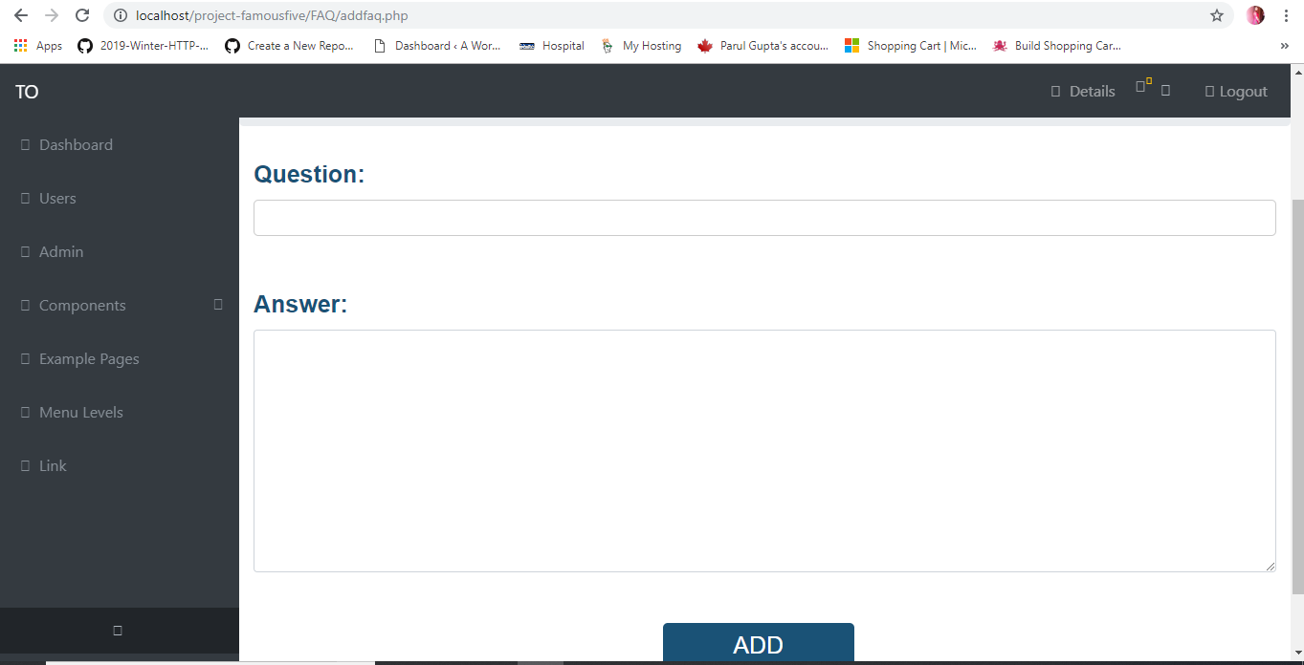

After Add it will directly take you to list faq:

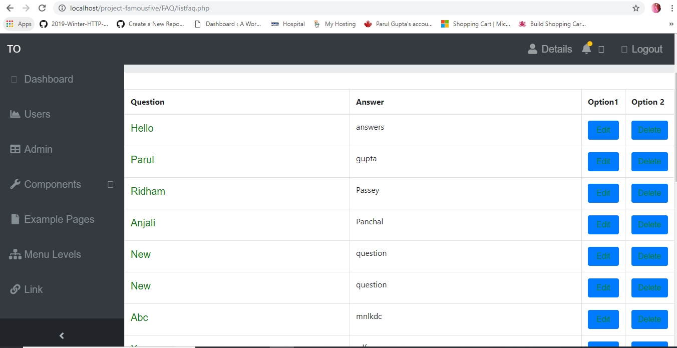

If you choose Option 1 Edit:

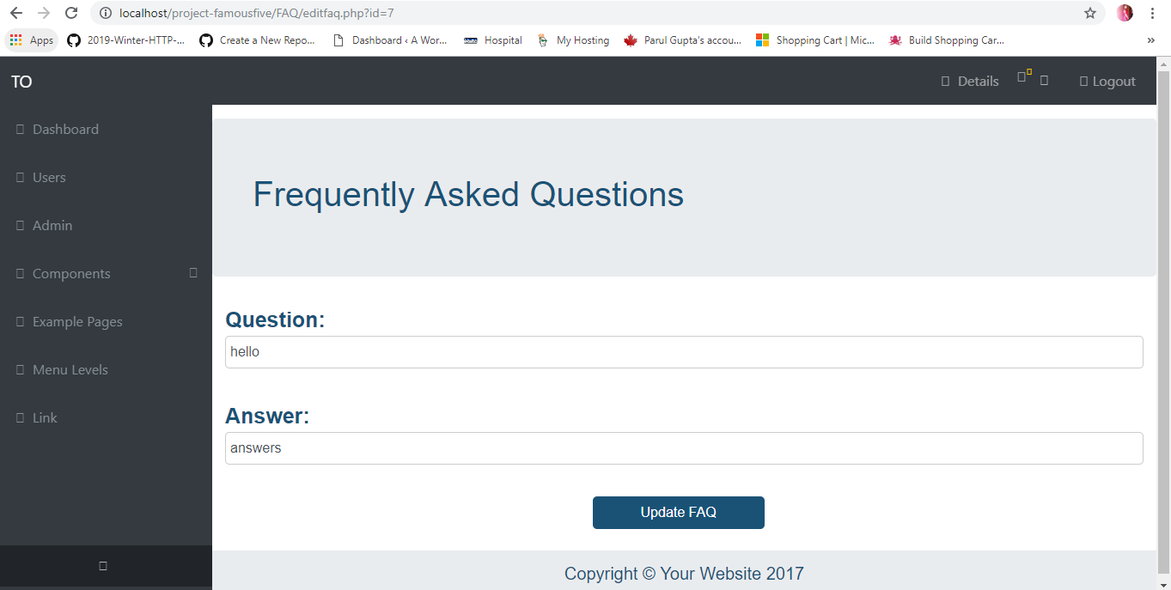

If you choose second option delete it will delete it and redirect to list page.

If we click on the link it will take you to the detail page:

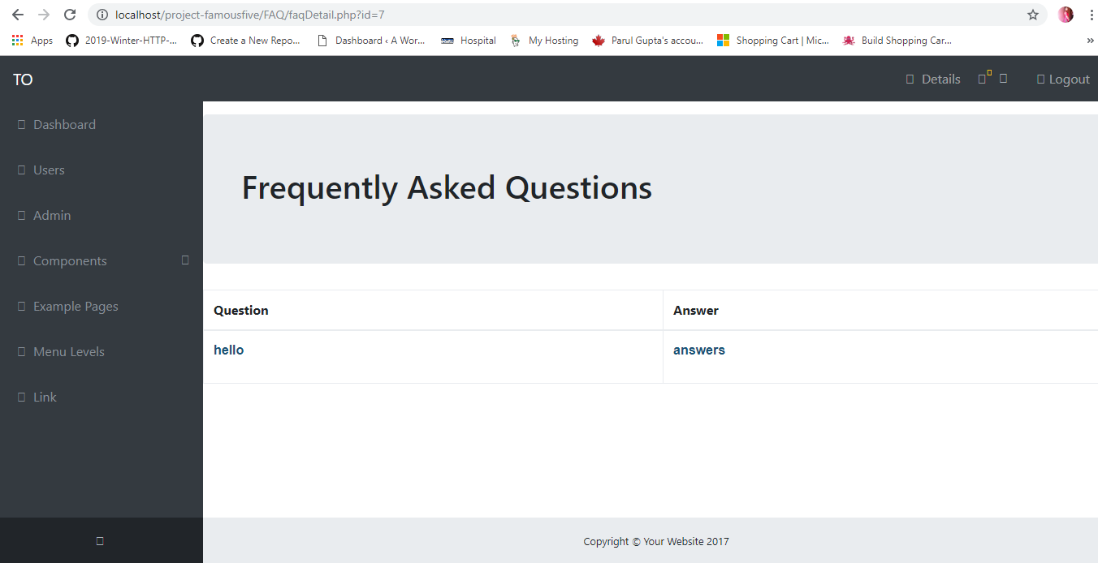

User View: First it will display like this only questions

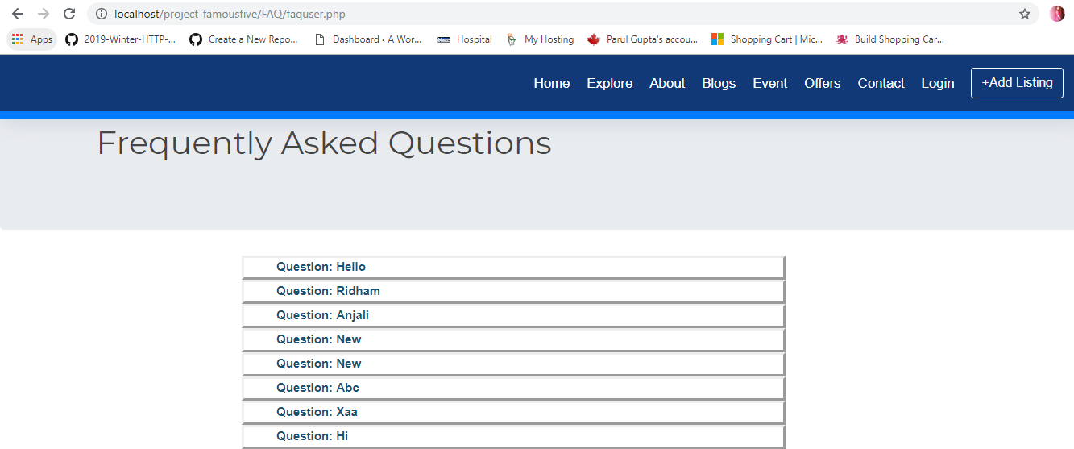

When user clicks on the questions the the answers will be visible.

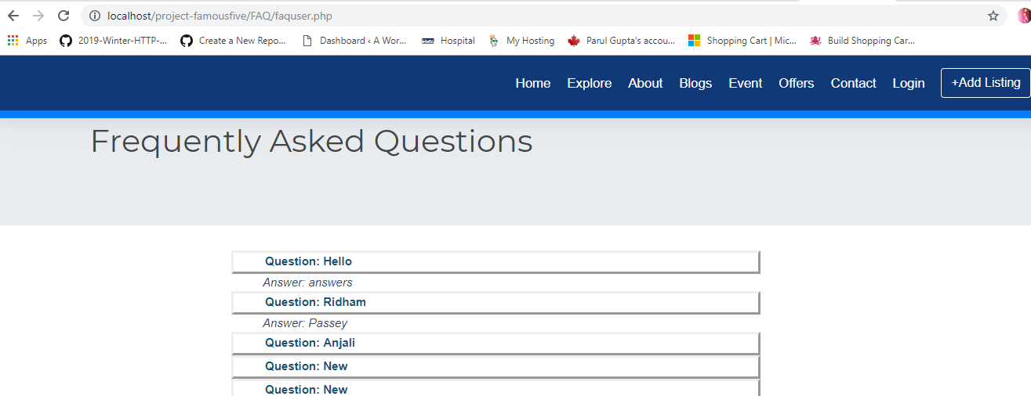

Offers:

Add offers:

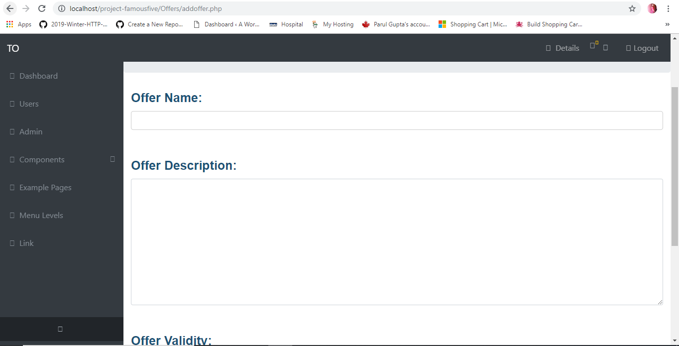

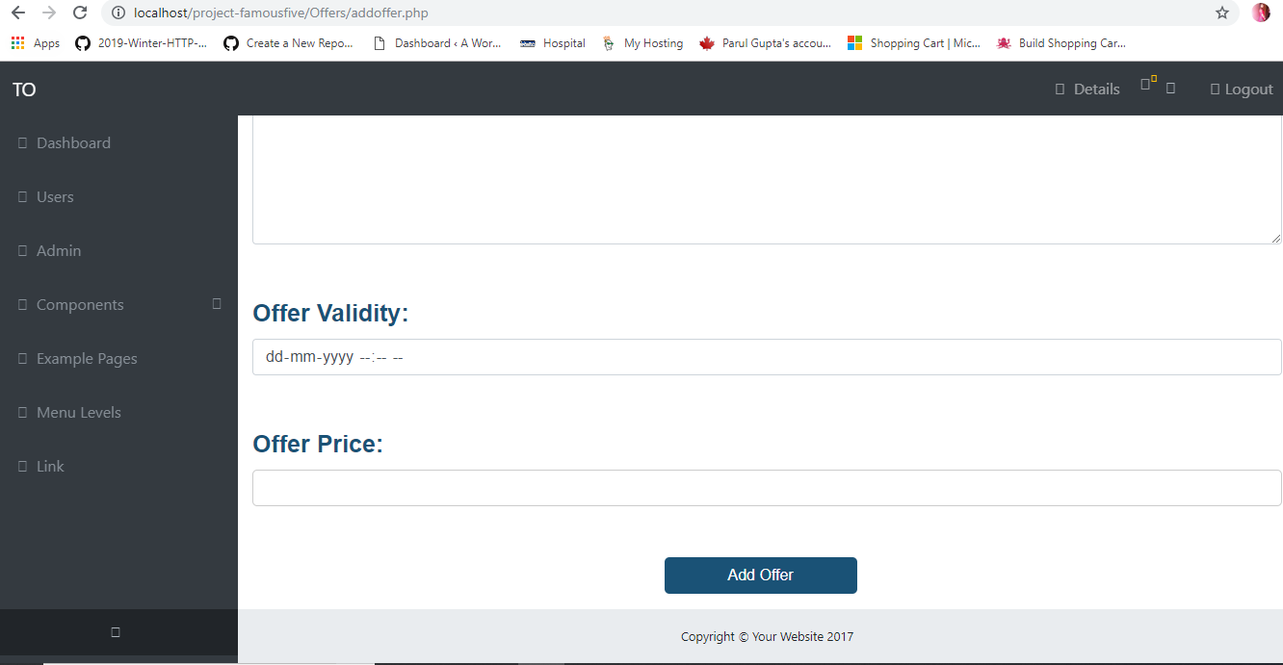

If there is no error after add offer it will redirect to list offer:

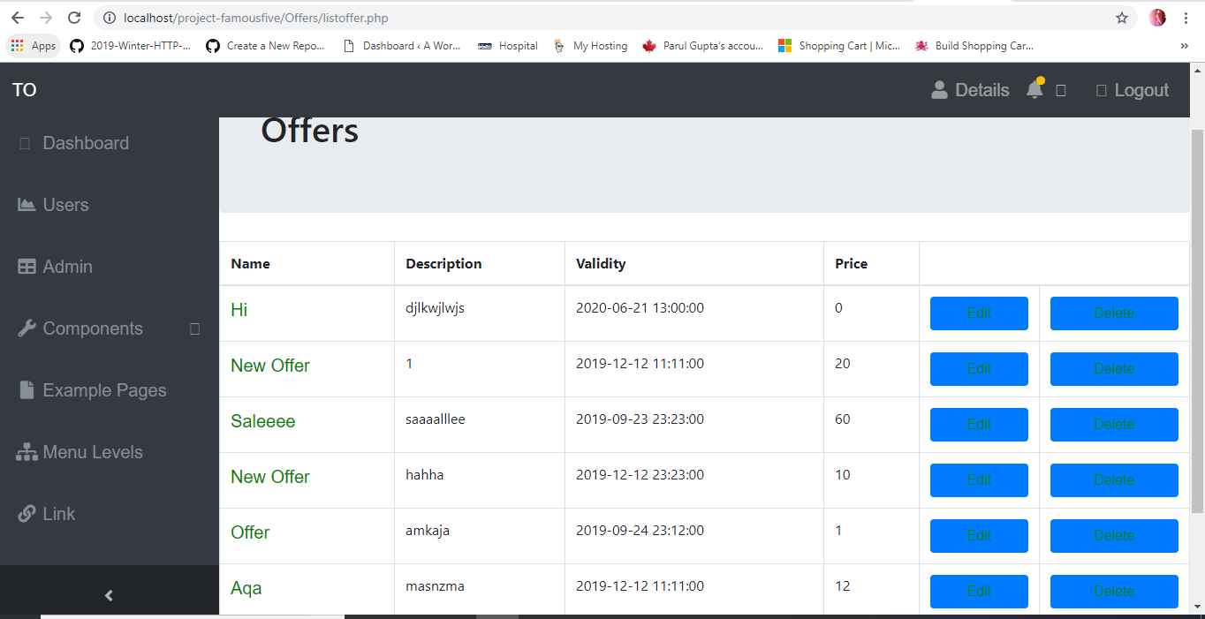

When admin clicks edit:

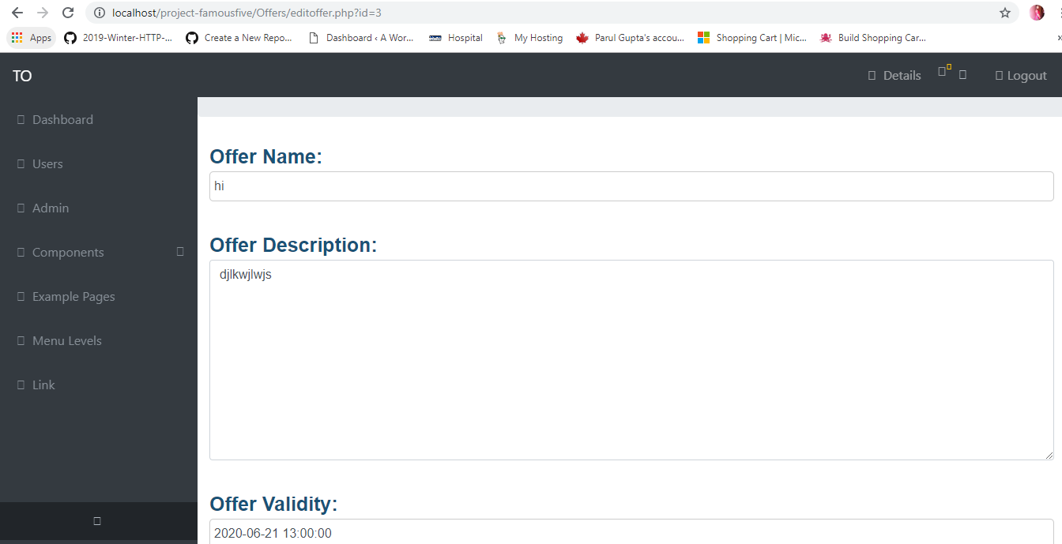

If admin clicks it will delete it and redirect to listoffer

When user click the offer name it will redirect to offer details:

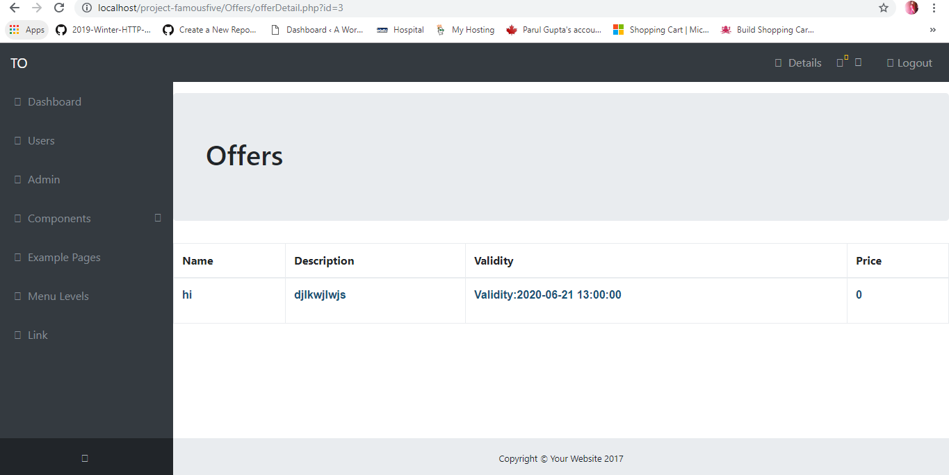

User view for offers:

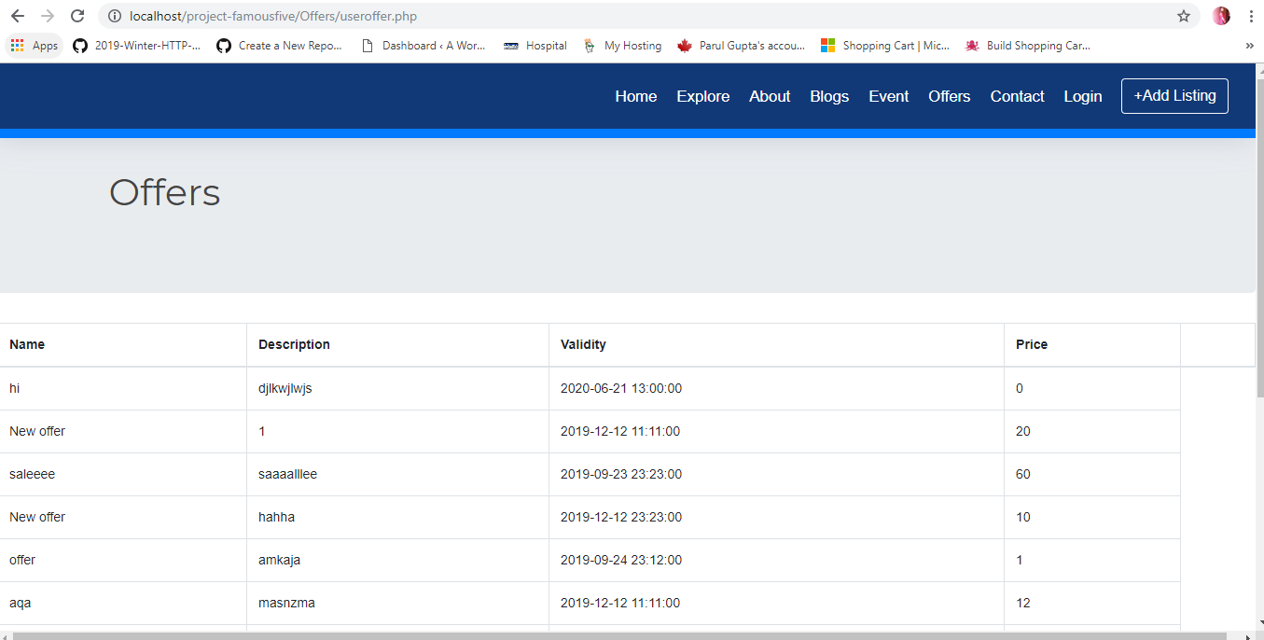

Contact us:

User Page:

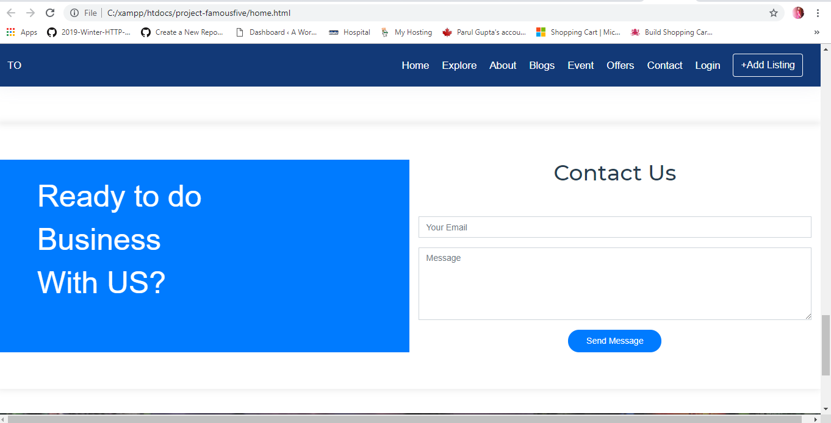

When user submits the form they can see the message saying thank you for your email

Admin:

Admin can see the users who submit the message and can see their details:

